World Interfaith Harmony Week 2026
RELIGIOUS FREEDOM IN PLURALISTIC SOCIETIES
Collective Responsibility in Countering Discrimination, Hate, and Intolerance
Journalists and Writers Foundation
(February 10, 2026)

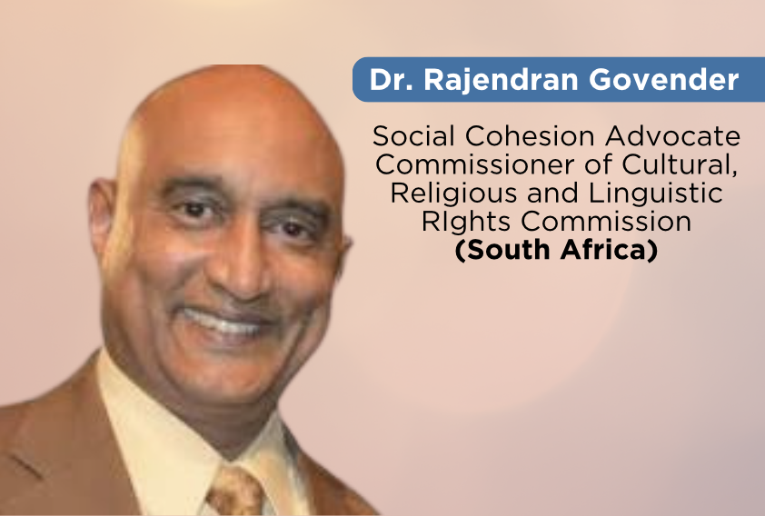
Reflections By
Dr. Rajendran Govender
Commissioner of the Cultural, Religious and Linguistic Rights Commission of South Africa, JWF Advisory Board Member (Interfaith Committee)

It was an honor to moderate the panel discussion hosted by the Journalists and Writers Foundation under the theme “Religious Freedom in Pluralistic Societies: Collective Responsibility in Countering Discrimination, Hate, and Intolerance.”
The session brought together distinguished scholars, theologians, legal practitioners, and civil society leaders from multiple regions. The diversity of perspectives enriched the dialogue and reinforced the global relevance of protecting religious freedom in increasingly pluralistic societies.
The online format was efficiently managed by JWF, allowing seamless engagement between panelists and participants. Audience participation through thoughtful questions further deepened the discussion and contributed meaningfully to the session’s success.

Why is religious freedom essential for inclusive and democratic societies?
Religious freedom was affirmed as a foundational democratic principle safeguarding human dignity and freedom of conscience. Panelists emphasized that democracies thrive when diversity is accommodated rather than suppressed, and that protecting minority communities strengthens social cohesion and constitutional integrity.

How do discrimination and religious hatred take root within communities?
Discrimination often begins subtly through stereotypes, misinformation, exclusion, and political manipulation of identity. Socioeconomic inequalities, unresolved historical grievances, and digital misinformation were identified as catalysts that amplify division.

What roles do families, faith institutions, schools, and civil society play in promoting tolerance?
Families shape early values of empathy and respect. Faith institutions model inclusive leadership and condemn hate. Schools promote religious literacy and critical thinking. Civil society facilitates dialogue, advocacy, and community-building initiatives.

How can interfaith dialogue move beyond symbolism to lived social practice?
Panelists encouraged moving from ceremonial dialogue to sustained collaboration through joint community projects, humanitarian initiatives, and long-term partnerships that embed interfaith engagement into everyday practice.

How should public speech be guided ethically in diverse societies?
Public speech should be anchored in dignity, responsibility, and mutual respect. Leaders bear heightened responsibility to avoid inflammatory rhetoric. Freedom of expression must not enable incitement or dehumanization.

How can societies help prevent societal polarization and ideological extremism?
Preventative strategies include inclusive education, strengthening democratic institutions, addressing structural inequalities, encouraging cross-community engagement, and promoting responsible digital governance.

Audience Engagement
The online audience actively participated, posing thoughtful and nuanced questions. Panelists responded with clarity and depth, demonstrating scholarly expertise and practical insight. The engagement reflected the global relevance of the theme and reinforced the need for continued dialogue on religious freedom.

Overall Assessment
The session was intellectually rigorous, globally representative, solution-oriented, and respectful. The Journalists and Writers Foundation is commended for curating a diverse panel and facilitating an efficient virtual platform that enabled meaningful global engagement.

Concluding Reflection
The discussion reaffirmed that religious freedom is not simply about protecting belief, but about safeguarding coexistence, democratic integrity, and human dignity in pluralistic societies.
Tolerance must evolve into solidarity, and dialogue must evolve into shared responsibility.
Submitted by:
Dr Rajendran Govender
Moderator
Commissioner: CRL Rights Commission (South Africa)

